Hawthorn Primary School

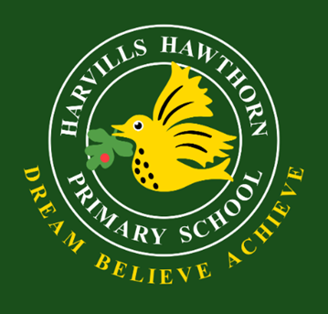 School Uniform Policy

Dated: July 2025

 Review: July 2026

Aims and objectives

Our policy on school uniform is based on the belief that school uniform:

* + promotes a sense of pride in our school;
  + helps to create a sense of community and belonging towards the school;
  + identifies the children with the school;
  + supports our commitment to inclusion;
  + is practical, smart and designed with health and safety in mind;
  + is considered good value for money by parents;

Expectations

We expect all pupils to comply with this uniform policy, which will be monitored. Parents requiring support to provide uniform should contact the school office and ask for our Family Worker.

The Role of Parents

We believe that one of the responsibilities of parents is to ensure that their child has the correct uniform and PE kit, and that it is clean, in good repair and that the child’s name is labelled on all items.

The Role of Governors

The governing body supports the Headteacher in implementing the School Uniform Policy. It considers all representations from parents regarding the uniform policy and liaises with the Headteacher to ensure that the policy is implemented fairly and with sensitivity. It is the governors’ responsibility to ensure that the school uniform meets all regulations concerning equal opportunities. Governors ensure that the school Uniform Policy enables children to dress sensibly, in clothing that is hardwearing, safe and practical.

Where to buy School uniform

Items with our logo embroidered can be purchased from Ian Smith online: <https://harvillshawthorn.secure-decoration.com/> or Brigade online: <http://www.brigade.uk.com/>

Or

CC Uniforms Ltd  
82 Kings Square, West Bromwich, B70 7NW.

Uniform can also be purchased from most major stores at competitive prices.

Uniform Swap Shop

Our Parent Teacher’s Association (PTA) also operate a termly Swap Shop where uniform can be donated and received by parents for free. If parents would like to donate to the PTA, they can and any funds raised go into the PTA funds and are spent on specific projects outlined at the time.

School Uniform List

* **White** polo shirt
* Green jumper or cardigan – preferably with logo
* Grey skirt or trousers
* Yellow or green gingham dress in the summer (optional)
* Grey shorts in the summer (optional)
* Black shoes

School bags

* Small backpack that can fit into a locker (optional)
* School book bag (Early Years and KS1)

P.E. Kit

* black shorts / leggings/ tracksuit bottoms
* White T-shirt
* House colour t-shirt for Sports Day and House events
* For winter months joggers and sweatshirt
* Rubber soled pumps
* Years 1-6 may wear trainers instead of pumps for outdoor games
* Drawstring pump bag

Headscarves/Hijjab

These may be worn for religious reasons and should be in school colours – green, gold, black, or white

A school policy for religious ceremonial wear has been adopted by the governing body. Please ask in school for further information.

Jewellery

It is not appropriate for children to wear jewellery except a sensible watch and a pair of small plain stud earrings.

Equality Impact Assessment

We as a school community have a commitment to promote equality. Therefore, an equality impact assessment has been undertaken and we believe this policy is in line with the Equality Act 2010 as it is fair, it does not prioritise or disadvantage any pupil and it helps to promote equality at this school.

Monitoring and Review

The governing body monitors and reviews the school uniform policy through its committee work by: seeking the views of parents, to ensure that they agree with and support the policy; considering, with the Headteacher, any requests from parents for individual children to have special dispensation with regard to school uniform;

July 2025